**TTGO LoRa32 SX1276 OLED Board**

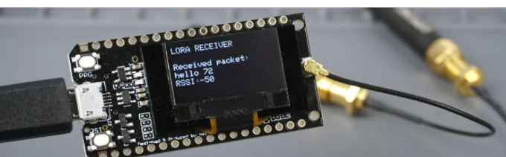

The **TTGO LoRa32 SX1276 OLED** is an ESP32 development board with a built-in LoRa chip and an SSD1306 0.96 inch OLED display.

File / Preferences

Enter **https://dl.espressif.com/dl/package_esp32_index.json** into the “Additional Board Manager URLs”

https://dl.espressif.com/dl/package_esp32_index.json, http://arduino.esp8266.com/stable/package_esp8266com_index.json

Open the Boards Manager. Go to **Tools** > **Board** > **Boards Manager…**

Search for **ESP32** and press install button for the “**ESP32 by Espressif Systems**“:

1. Open your Arduino IDE and go to **Sketch**> **Include Library** > **Manage Libraries**. The Library Manager should open.

2. Type “**SSD1306**” in the search box and install the SSD1306 library from Adafruit.

3. Type “**GFX**” in the search box and install the library.

#include <Wire.h>

#include <Adafruit_GFX.h>

#include <Adafruit_SSD1306.h>

The OLED displays communicates using [I2C communication protocol](https://randomnerdtutorials.com/esp32-i2c-communication-arduino-ide/). It is internally connected to the ESP32 on the following pins:

|  |  |
| --- | --- |
| **OLED** (built-in) | **ESP32** |
| **SDA** | GPIO 4 |
| **SCL** | GPIO 15 |
| **RST** | GPIO 16 |

Define the OLED pins.

#define OLED_SDA 4

#define OLED_SCL 15

#define OLED_RST 16

#define SCREEN_WIDTH 128 // OLED display width, in pixels

#define SCREEN_HEIGHT 64 // OLED display height, in pixels

Adafruit_SSD1306 display(SCREEN_WIDTH, SCREEN_HEIGHT, &Wire, OLED_RST);

setup()

Initialize in setup the display with the following parameters.

The parameters set as false ensure that the library doesn’t use the default I2C pins and use the pins defined in the code (GPIO 4 and GPIO 15).

if(!display.begin(SSD1306_SWITCHCAPVCC, 0x3c, false, false)) { // Address 0x3C for 128x32

Serial.println(F("SSD1306 allocation failed"));

for(;;); // Don't proceed, loop forever

}

display.clearDisplay();

display.setTextColor(WHITE);

display.setTextSize(1);

display.setCursor(0,0);

display.print("LORA SENDER ");

display.display();

